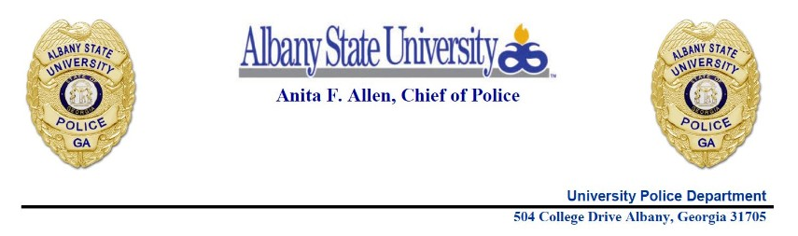

|  |
| --- |
| Albany State University Police Department  Recovered Property Notification List |
| Below you will find a list of items that have been recovered by the Albany State University Police Department. The items will be stored for four (4) weeks. At the end of (4) weeks, the items will be destroyed.  If you have lost an item, or had an item stolen, it fits the description of an item listed below, and you are able to show proof that it belongs to you, contact Albany State University Police Department at 229-430-0528 or 229-430-4711. |
|  |
| Itemized List for January 2025 includes: |
|  |
| Black Glasses |
| Grey Glasses |
| Tortoise Shell Glasses |
| White Apple Watch |
| Black Cash App Card |
| White Earbud Case (No Earbuds) |
| Teal Earbud Case (No Earbuds) |
| Black iPhone with Transparent Pink Case (Cracked Screen) |
| One Apple Air Pod in Lavender Case |
| Thick Braided Golden Bracelet |
| Pair of Apple Air Pods in White Case |
| Pair of Apple Air Pods in White Case with bank card |
| Silver Cross Rosary Necklace |
|  |
|  |
|  |
|  |
|  |
|  |
|  |
|  |